Why Do Snow Leopards Look the Way They Do?

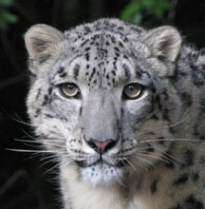
Photo of Asha by Steve Flaherty

The answer to this question is closely linked with the answer to the question, "Where do snow leopards live?" Snow leopards look the way they do as a result of adaptations to their environment. To put it another way: snow leopards look the way they do because of where, and how, they live.

