Where do snow leopards live?

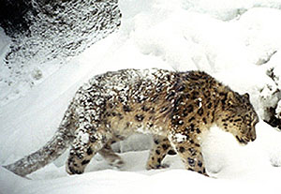
Summer or Winter, the living is seldom
easy for a snow leopard &ndash photo by Tashi Ghale.

Snow leopards are found in the mountains of Central Asia. Their range includes the Himalayan mountains of Tibet, Nepal, India, and Bhutan; Pakistan’s Karakorum and Hindu Kush; the high mountain ranges of Afghanistan, Mongolia, the People’s Republic of China, Russia and the former Soviet republics of Kazakhstan, Kyrgyzstan, Tajikistan and Uzbekistan. Snow leopard habitat is rugged and remote. These endangered big cats can even be found at the base of earth’s highest mountain, Mt. Everest, called Chomolungma by the people who live around it. Here you will find a map showing the snow leopard’s range.
Within their mountain habitat, snow leopards like high, steep and rocky places where there are few plants, places that scientists call the alpine and sub-alpine zones. Snow leopards live in the alpine zone in the warmer, summer months of the year. They come down into the sub-alpine zone in the colder, winter months following the animals that they hunt for food – the bharal or the ibex, that come down to lower elevations in search of winter grazing.

