What Kind Of Education
Does A Person Who Works
With Snow Leopards Need?

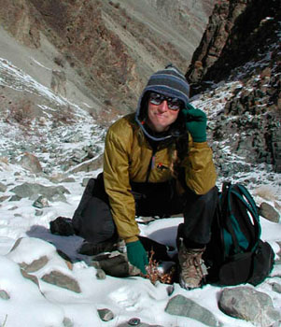
Wildlife biologist Barbara Palmer works in the cold and snow of Northern India to set a camera-trap.

Most entry-level zoo keeper positions now require a four-year college degree. Training in animal science, zoology, marine biology, conservation biology, wildlife management, and animal behavior is preferred. Curatorial, research, and conservation positions typically require advanced academic degrees. However, advanced academic training by itself is insufficient, and it may take years of “on-the-job training” for someone to learn the practical aspects of exotic animal care. A few institutions offer curatorial internships which are designed to provide practical experience. For working in the wild, a Master of Science degree in zoology, animal behavior or wildlife management would be required

