What are the laws against killing snow leopards?

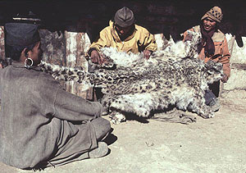

Despite the efforts of TRAFFIC, snow leopard skins can still be found for sale in some of the snow leopard countries. Also, the bones, skin and other organs of snow leopards are substituted for tiger parts in Asian traditional medicine. The cats are protected by law in nearly all twelve range countries, but it is almost impossible to enforce the laws in the snow leopard’s remote mountain habitat. They are listed in Appendix 1 (most endangered) of the United Nations Convention on International Trade in Endangered Species (CITES), which bans or strictly limits trade of animals or their body parts. As of 2007, only Tajikistan had yet to sign the CITES agreement.

