What adaptations have snow leopards made to their environment?

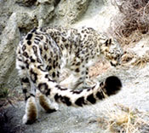

Photo by Tashi Ghale

Snow leopards are well adapted to their high altitude homes where they may encounter deep snow and rocky terrain with little vegetation. Snow leopards have a well-developed chest that helps them draw oxygen from the thin air of the high mountains. Snow leopards also have short forelimbs with sizeable paws, long hind limbs, and a thick tail nearly a meter long. These adaptations help them balance on the rocky precipices of their home. Adaptations for cold include an enlarged nasal cavity that allows them to warm the cold air they are about to take into their lungs. Other adaptations for cold include long body hair with a dense, woolly underfur, and a thick tail that can be wrapped around the body. The snow leopards pelage enables them to blend into their surroundings. Their wide feet act like snow shoes.

