How many Snow Leopards are living in zoos?

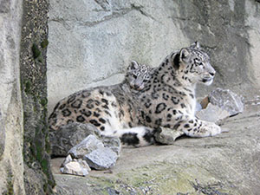
This photograph of Dshamilja and her cub, Gul’cha was taken by Dr. Georges Barth. Dshamilja and Gul’cha live in Switzerland at the Zurich Zoo. For more pictures of Dshamilja and Gul’cha, go to our photo section.

There are approximately 600 snow leopards living in accredited zoos worldwide including approximately 250 in American zoos. Suitable mates are selected under the guidance of the Species Survival Plan for snow leopards.

What About Reintroduction?
The American Zoo and Aquarium Association’s Species Survival Plan program was initiated in 1981, and includes a plan for snow leopards. Under this program, zoos cooperate to manage individual animals as a single population. While this program will ensure that snow leopards do not become extinct, reintroducing snow leopards into their natural habitat is not a viable option at this time. We need more information about their status in the wild. Their habitat must be preserved. We must work on the problems of conflicts between people and wildlife.

