How many cubs are in a snow leopard litter?

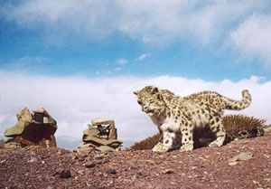
Do you see two snow leopard cubs in this photo?

There is not enough data to draw conclusions about litter size in the wild. In captivity, female snow leopards most often bear 2 or 3 cubs in a litter, though there can be more. The mating season is January to mid-March, and most births occur in May and June. The cubs will stay with the mother for 18 to 22 months, and siblings may stay together briefly after the mother leaves.

