How long do snow leopards live?

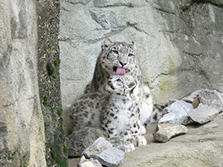
Dshamilja and her cub, Gul’cha photographed by Dr. Georges Barth. For more pictures of Dshamilja and Gul’cha, go to our photo section.

In captivity, snow leopards have been known to live for as long as 21 years. Their lives in the wild are much harder, so they are undoubtedly much shorter. However, there is not enough scientific data about snow leopards in the wild for scientists to know for sure how long they live.

