How Fast Can a Snow Leopard Run?

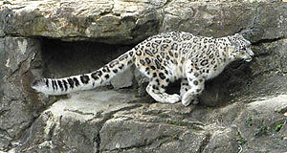
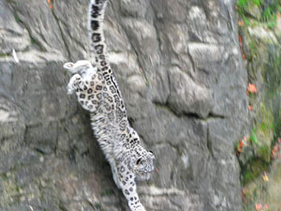
These photos of Dshamilja were taken at the Zurich Zoo by Dr. Georges Barth. For more pictures of Dshamilja, go to our photo section.
Snow leopards are capable of running very fast for short distances. However, the ability to run fast is not a particularadaptation of this big cat. The fastest cat, the cheetah, lives in open habitat where it is difficult to sneak up on prey. The cheetah must use its speed when it wants to grab a bite. Snow leopards live in craggy, mountainous areas, and they usually have to rush their prey at short distances. The ability to leap, bound and pounce have become this cat’s adaptations. Snow leopards have been known to leap as much as 30 feet.
Ounce for ounce
Ounce packs a pounce
In both running and leaping, the snow leopard is highly dependent on its tail for balance, and it is a tail unmatched by any other cat. It is covered with amazingly long, dense fur which makes it appear very thick. It can easily be as long as the cat’s body.

